FACILITIES SPACE REQUEST FORM
__________________________________________________________________________________________________
All Fields Required
General Information:
Requesting Group / Person: _____________________________
Requestor Contact Phone: ______________________________ Email:________________________
Request Date: _________________________________________
Space, bldg., room #, location_____________________________________________________________
Requested Duration: ____________________________________________________________________________
If this space request is temporary, please include the dates of the duration of this space request.

From: __________________ To: ___________________

Space Request Information:
- What steps have been taken to solve the space requirement; including review and consideration of existing space assigned to lower priority initiatives?

- Please provide the name of the person(s) or program that will be occupying the newly requested space, the reason why the space is being requested and the proposed functional use of the space:

- How would your unit be affected if the requested space is not assigned and what is your alternative plan?

- Does this request include the need for space renovation? If so, what, and does the unit have funding in place to accommodate associated costs?

- Will this change result in vacated space? Yes_______ No_______
If yes, please list the building, floor and room to be vacated.

- Will this request, if granted, affect any other individual(s) / unit in any fashion? If yes, please provide detail of plan / suggestion to be considered to accommodate those issues:

- Please provide any additional information that will support or better define this space request.

- Please attach a floor plan (UNM FAMIS visual map) identifying space consideration,
(UNM-G FMD can assist with providing building floor plans / maps).
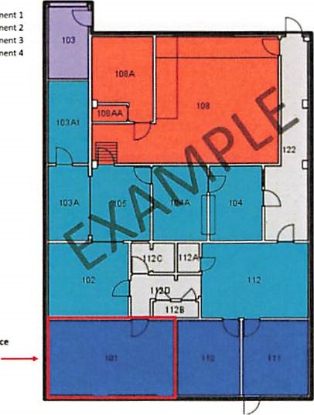

The signatures below indicate agreement that this space request should be reviewed. Approval to proceed with the analysis of this request does not imply any commitment for the assignment of space. All signatures are required.

Requestor: _________________________ ______________________
Signature DATE

Supervisor: _________________________ ______________________
Signature DATE

Director/Dean: _________________________ ______________________
Signature DATE

______________________________________________________________________________________

Determination: Approved ________ Tabled / pending ________ Disapproved ________

Facilities Committee Chair _________________________ ______________________
Signature DATE

*Campus space utilization is determined by the needs of the institution; no space assignment is permanent.

SPACE PREPERATION CHECKLIST:

IS ALTERATION REQUIRED

FLOORING / CARPET

PAINTING REQUIRED

NOTE OTHER REPAIRS NEEDED

FURNITURE STATUS

PHONE / VOICEMAIL REQUIREMENTS

IT / DATA REQUIRMENTS

SIGNAGE / WAYFINDING

